Bee visitation, pollination services, and plant yield in commodity and hybrid seed canola

Samuel V. J. Robinson[1], Ralph V. Cartar,  
Stephen F. Pernal, Riley Waytes, Shelley E. Hoover

Department of Biological Sciences, University of Calgary, Calgary, AB  
 Agriculture and Agri-Food Canada, Beaverlodge Research Farm, Beaverlodge, AB  
 Ministry of Land, Water, and Resource Stewardship, Smithers, BC  
 Department of Biological Sciences, University of Lethbridge, Lethbridge, AB

Insect-mediated pollination of crops is an important service to agricultural production, but pollination management suffers from key knowledge gaps that hinder its greater utility. While a solid theoretical and mechanistic framework for plant pollination exists, the pollination of agricultural crops is often treated as a “black box”, without reference to the specific mechanisms underlying the processes of pollination and fruit production. We present a causal model that links insect visitation to pollination to three separate components of yield, using field data from two types of canola (*Brassica napus*) production systems. Our results demonstrate that yield in commodity canola fields is primarily determined by plant size, and we found no relationship between honey bee visitation and pollen deposition, or pollen deposition and seed yield. In contrast, yield in seed production canola fields was similarly controlled by plant size, but there was also a strong relationship between bee visitation and pollen deposition, as well as deposition and seed yield. Leafcutting bee visitation in particular strongly increased pollen deposition in seed canola fields, whereas honey bee visitation did not. This model serves as a step towards a dynamic model of pollination services, and points to the contextual importance of pollination services in seed canola production.

# Introduction

Animal pollination of agricultural flowering plants is an important ecosystem service that contributes to about 10% of total crop production value worldwide , and animal-pollinated plants produce a large number of important micronutrients in the human diet . Pollination of these crops, however, is largely treated as a single step, while in reality there are many links in the chain of events that result in fruit production. Visitation of flowers by animals (typically bees or other insects) can increase the deposition of pollen onto the stigma of the flower, but in order for fruit set to occur, this must be followed by fertilization of the ovules, and maturation of fruit . Each step has many other underlying constituent components (*e.g.* stigma receptivity, pollen tube growth, ovule abortion), but even at this coarse level of approximation, most studies of agricultural pollination fail to account for important underlying processes. Moving beyond this “black-box" model of agricultural pollination requires incorporation of these steps, and is needed for contextualizing the value of pollination services, as well as optimizing crop yield in novel circumstances.

Pollinator visitation is not uniform within fields: visitation rates typically decline with distance away from the pollinators’ nest sites. Smaller bees fly shorter distances than larger bees , so their presence at the centre of large fields can be limited . Hence, managing the location and density of pollinators is important for optimal yield of pollinator-dependent crops . Similarly, foragers will often specialize on certain species or morphs of flowers in order to forage more efficiently (floral fidelity, ). Pollination of hybrid seed crops presents a challenge for specialized foragers, as it requires movement of pollen between separate lines of plants, meaning that fidelity can reduce pollen transfer . Competition for floral resources can occur between different species of foragers, but they can spatially or temporally separate their foraging to reduce competition (, but see ), such as switching between floral morphs more often, or visiting less frequently . Thus, variation in visitation can be driven by distance, competition with other foragers, or floral specialization, as well as plant traits such as nectar production and flower size; however, this spatial variation is seldom considered, as commercial pollinators are often treated as a single agricultural “input" (akin to fertilizer).

Seed production can be limited by plant resources as well as pollen, meaning that the benefits of insect pollination depend on the resources available to the plant . Pollination can enhance fruit production in flowering plants by increasing either the quantity or quality of pollen deposited on the stigma . Many flowering plant species are capable of self-pollination, but can produce more fruit or seeds from outcrossed pollen . However, the returns from this extra pollen deposition are diminishing , with very high numbers of pollen grains causing decreasing improvements in fruit production . Pollen limitation can also occur at multiple levels within a plant, reducing the number of seeds per fruit or the number of mature fruit . Low pollen deposition can also cause flower abortion, where poorly-pollinated flowers are abcised from the plant ; an indeterminate growth strategy may offset this by enabling the plant to continue producing more flowers . Additional pollen may result in a greater number of seeds per fruit , which in turn may result in a reduction in the size per seed due to competition between ovules or fruit . Seed size can also vary dramatically among plants, and can be affected by resources available to the plant . Therefore, understanding how plants allocate reproduction under pollen or resource deficits are important for managing agricultural production .

Insect pollination is especially important in the production of canola (*Brassica napus* L.). Hybrid *commodity canola* (used for oil and meal production) is the offspring of two parental *seed canola* breeding lines, a male-sterile “female" and a hermaphroditic “male" line . Seed canola production therefore requires a large number of pollinators to ensure pollen transfer from the male to the female line (seeds from the male line are not harvested), but there are few studies that examine pollination in these seed production systems (but see ). Bee pollination may also increase the yield of commodity canola , but this is unclear, as many key studies suffer from either a lack of realistic context, have a number of potential confounding variables, or infer plant-level outcomes from flower-level treatments . Greenhouse experiments typically involve unrealistically high levels of pollination, nutrient availability, and water, all of which can interact with yield . Field studies often relate yield to indirect measures of pollination services, such as species richness or distance from sources of potential pollinators, or do not examine production at the plant level . These proxies provide limited information about how plants dynamically respond to pollen exclusion or addition (but see ). Net- or cage-treatments exclude insect visitation from certain plants or flowers, but can alter wind pollination, humidity, light, or pest pressure . All of these methods give an incomplete picture of how pollination relates to yield in canola crops , and obscure estimates of pollinator value in a globally valuable crop species .

Seed production in canola involves a sequence of processes (visitation pollen deposition fruit production plant resources), that determine the magnitude of the link between pollination and the components of crop yield (seed size/number). However, other studies of canola pollination focus on individual processes, such as visitation and pollination , or visitation and yield , but have not incorporated the links in a single framework (but see ), and few have used realistic field data . In this study, we examine how distance influences pollinator visitation, which in turn influences pollen deposition and seed yield, using commodity and seed canola crops in Alberta, Canada. Using both commodity and seed canola provides an opportunity to compare two plant varieties that differ strongly in their pollination requirements, using a similar type of structural model, while accounting for agricultural differences between varieties. We expected that bee visitation would decrease with distance from each species’ hive or shelter, and that lower visitation would result in lower pollen deposition. We also expected that higher pollination would increase seed production in commodity canola crops, but that the magnitude of the increase would be higher in seed canola, and that plant size (a proxy for plant resources) would similarly increase seed production. This study assesses the strength of the connections between visitation, pollination, and yield, in a globally important crop species, and identifies the relative importance of bee pollination for seed production, using in-field data from two distinct cropping systems.

# Methods

## Data collection

From June through August of 2014 and 2015, we surveyed 29 commodity canola fields (14 in 2014, 15 in 2015) near Beaverlodge, Alberta and 31 fields (17 in 2014, 14 in 2015) near Lethbridge, Alberta (Figure S1). Commodity canola fields were selected based on the proximity of honey bee apiaries and site access. 28 of the 60 fields were stocked with Western honey bees (*Apis mellifera* L., hereafter HB) at the corner or side of the field (mean: 0.6 hives/hectare, SD: 0.58) while 32 fields were unstocked. 14 of 31 of the fields near Lethbridge were watered using central-pivot irrigation systems. Growers were also asked for canola variety information, but there was not enough replication to test for difference between varieties.

During 2015 and 2016, we also surveyed 35 hybrid seed canola fields (15 in 2015, 20 in 2016) near Lethbridge, Alberta, from June through August of each year, all of which had central-pivot irrigation, and were stocked with honey bee hives at a rate of 3.6 hives/ha (apiaries stationed in the corners of fields). In seed fields, bays of hermaphroditic (herafter “male") and female plants are typically planted in 1- and 6-m wide bays, respectively. Seed fields were also stocked with shelters (1.3 - 2.6 shelters/ha, Figure 7) containing alfalfa leafcutter bee cocoons (*Megachile rotundata* F., hereafter LCB) at a rate of 50-100,000 coocoons/ha.

In both field types, we established set of plots at varying distance from the sources of pollinators. In commodity fields, plots were located at 1 m plots at 5, 20, 100, and 500 m (271 total plots), starting at the field edge closest to the set of honey bee hives or potential sources of natural pollinating insects in unstocked fields (forests, shrublands, or grasslands). We observed very few wild pollinators (Table S2), so these were excluded from the analysis. In seed fields, we established plots at 5, 20, 100 (250 m in 2016), and 400 m into the field along a transect from the nearest set of honey bee hives, using pairs of plots at the edge of adjacent male and female bays (Figure 8). To examine within-bay variation in visitation, we established a plot at the centre of the female bay at the 5m and 400m plot in each field. Distances to nearest shelters were measured using a NikonLaser 800S Rangefinder. Finally, we incorporated plot-level visitation data from Waytes (; same years and locations) to more accurately gauge the effect of distance from shelter on visitation rates (647 total plots). All surveys occurred on fair-weather days (median temperature: 24.5C., range: 17–33) with no rain and minimal wind (30 km/hr).

Insect visitation and pollination data were collected once during the main canola bloom at each field (late June - late July), and plants were collected just prior to harvest (mid - late August). We recorded the number of insect visits that contacted the stigmas and anthers of flowers during 10 min of observation (5 min for seed fields during 2015), recorded the identity of the visitor, and counted the number of open, visitable flowers in each plot (petals had not yet started to dehisce, style had not elongated more than 3-4 millimeters beyond the anthers). To assess pollen deposition, we collected stigmas from five random flowers at each female plot, mounted them in fuchsin gel on depression slides, and counted the pollen on each stigma using a LeicaDME 13595 light microscope under 100x magnification (1294 commodity and 1050 seed canola stigmas). At the end of the growing season, we collected three plants from the same female plot and recorded the plant density per m (789 commodity canola plants, 582 seed canola plants). After drying the plants, we weighed each plant, counted mature pods to estimate pod set, and counted the number of flower pedicels to estimate total flower production. We estimated seed size and seeds per pod by averaging the seed count and weight from five pods on each plant. Finally, we threshed all the pods for each plant by hand, winnowed them using an air separator, and weighed the total mass of cleaned seeds.

## Analysis

To examine how yield is influenced by visitation, we used piecewise structural equation models (pSEM, ). Structural equation models (SEMs) are a set of linear models arranged in a causal network, which provides a framework for testing hypotheses about complex systems . SEMs provide a framework for empirical analysis of complex systems, as they allow causal relationships to be formally tested, can provide insight into alternative mechanisms, and are flexible in their assumptions. SEMs represent an intermediate class of statistical models, occupying a space somewhere between linear regression (or machine learning) models and dynamic linear models, making them ideal for generating and testing relationships between large sets of variables . Starting with a simple model (visitation pollen deposition fruit production plant resources), we built a detailed model relating visitation to pollination to seed yield within a causal framework (see Figure 1). We also ran a linear model outside of each SEM to predict total yield (g per plant) as a function of the seed size, seeds per pod, and pods per plant (see Table S6). After the models were fit and validated, we simulated seed size and yield at varying distances from pollinators, using the coefficients from each model to integrate the effect of pollination on yield across all sub-models (while holding plant density constant).

The underlying models of each pSEM were specified as generalized linear mixed-effects models (GLMMs). GLMMs can model processes that occur at different levels; for example, we modeled seed size at the plant level, and pollen deposition at the flower level. Random intercepts were used to model variance at the field and plot level, but plot-level variance terms had poor traces and low effective sample sizes, indicating low plot-level variance; therefore, we omitted plot-level random effects for all models (except for pollen count and pod set in seed fields, see Table S5). Visitation models used (time) as an “offset" variable to account for differences in observation times. We observed LCBs directly harassing HBs during the plot-level observations, attacking HBs both on the flowers and in the air (also seen by and ), but HBs were never the aggressor in these interactions, so we treated LCB visitation as a potential cause of HB visitation (Figure 1). Pod set can suppress future vegetative growth and flower production , but SEMs do not allow for causal loops , so we included a path from pod set to flower production as the closest approximation of this process. The direction of the path could be reversed, implying that large flower production reduces the proportion of pod set, but we considered only the first scenario, as showed that low pod set increases flower production. Plant and pollen samples were not collected from male bays in seed fields, and there were no large differences in visitation rates for honey bees or LCBs (p = 0.32, 0.72, respectively) once other terms were included as covariates, so bay was excluded from further analysis. See Equation sets S1 and S2 for model specifications) and Table S1 for a brief summary of the variables used in each SEM.

Structural equation models do not have paths between all variables, which may bias the model results if this independence assumption is incorrect; this requires testing a “basis set" of independence claims using Shipley’s d-separation criteria . The initial commodity canola pSEM was misspecfied, as several missing paths were identified (Fisher’s C = 167.5, df = 64, p0.001), but the updated pSEM was deemed adequate (C = 52.0, df = 48, p = 0.32). Similarly, the initial seed field pSEM also had several missing paths (C = 105.6, df = 76, p = 0.01), which were added, making the updated pSEM adequate (C = 72.2, k = 72, p = 0.47). Basis sets were generated using the dagitty library in R 4.2.1.

All component GLMMs of the pSEM were written in Stan 2.18.1 and run using rstan 2.26.13 . We used weakly informative normal priors () for fixed effects and gamma priors () for the variance components. Four separate chains were run with an adaptive phase of 1000 iterations, and a sampling phase of 1000 iterations, then checked for convergence of the chains (1) and low autocorrelation within chains (high ). We assessed the underlying probability distribution functions of each model using posterior predictive checks , and found that the probability distributions were properly specified (i.e. simulated data was close to actual data). p-values were calculated using the Z-scores (mean/SD) of the sampled posterior distributions; unless otherwise specified, listed model coefficents have a p-value less than 0.05, and are considered “strong" effects where p-values are (see Table 4 and 5 for more detailed model summaries). Predictions from models are taken from median values of the posterior, while uncertainty is derived from the 95% credible intervals (CIs). Figures were made using ggplot2 and ggpubr .

# Results

## Path analyses

The path analyses revealed that plant size and pollen deposition were the main drivers of seed production in seed canola, while plant size alone was the main driver in commodity canola (see Figure 1 for paths and effect sizes). LCB visitation strongly increased pollen deposition in seed canola, but there was no strong effect of HB visitation in either seed or commodity canola. Plant size increased with distance from the edge of the field in both crops, as well as plant density in seed fields. Plant size strongly increased the number of flowers per plant in both crops, and there were strong negative paths from pods per plant to flowers per plant, indicating that high flower survival suppressed future flower production in both crops. Plant size increased pod set and seeds per pod in both crop types, and also increased seed size in seed canola plants. Pollen deposition increased pod set and seeds per pod in seed canola, but did not affect seed or pod production in commodity canola, showing that plant resources matter strongly for both crops, but that pollen limitation matters only in seed canola. Finally, there was a direct effect (i.e. not mediated by visitation) of bay centre, distance from edge, and distance from LCB shelter on pollen count and pod set in seed fields, pointing to possible differences in pollen transfer even at the same rate of visitation. We consider each component of each path analysis in greater detail below.

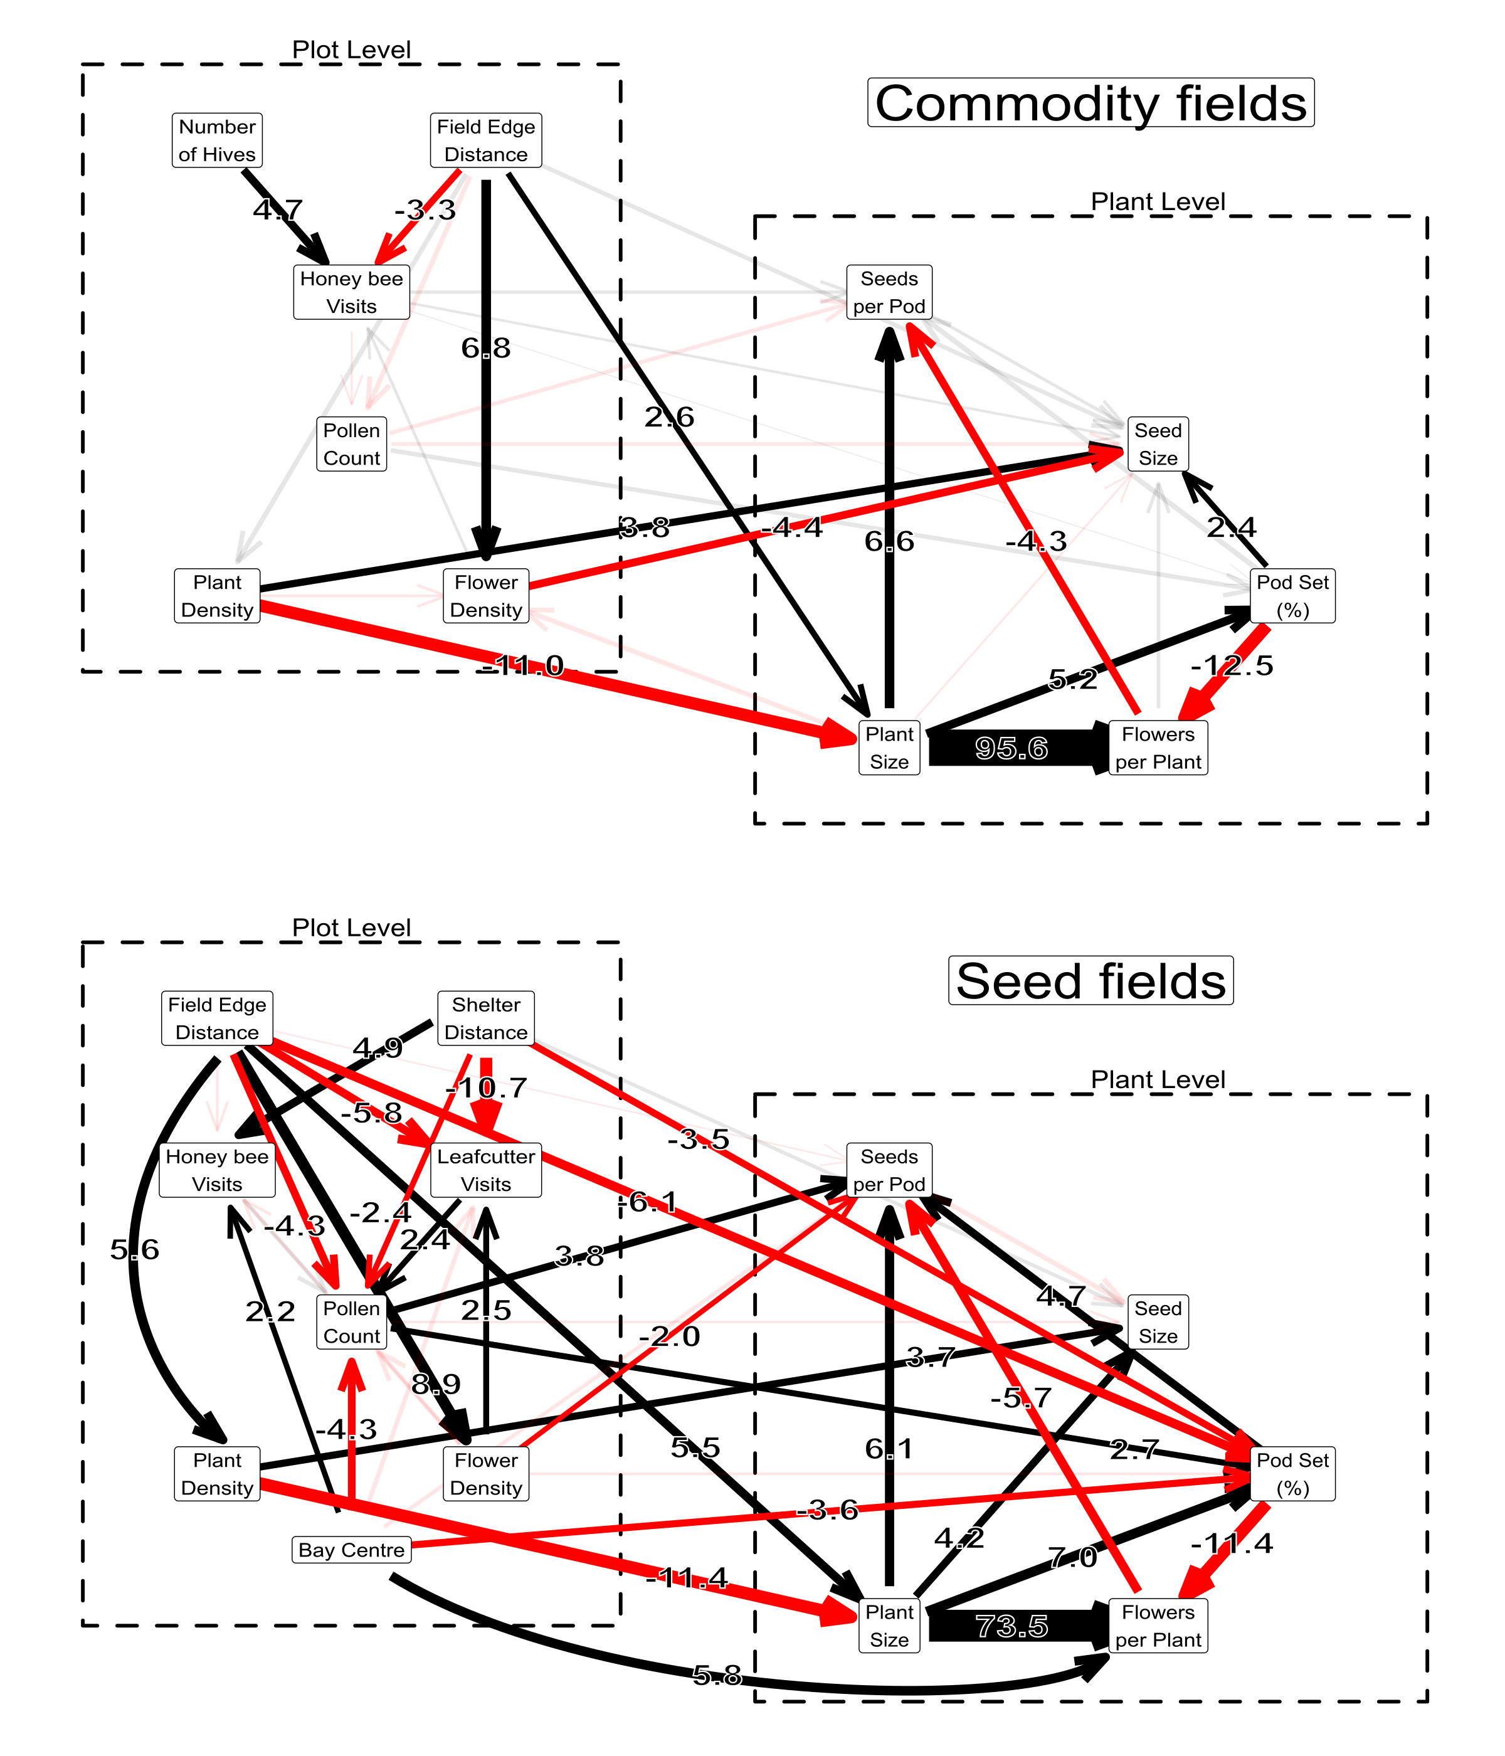

Results of path analyses in commodity and seed fields. Field Edge Distance refers to the distance to the edge of the field (and location of HB apiary) and Shelter Distance refers to the distance to the nearest LCB shelter. The width of each arrow is proportional to the effect size of each component path (number also displayed), with black and red lines representing positive and negative effects, respectively. Transparent arrows show path coefficients whose 95% posterior intervals overlapped zero.

## Flower Visitation

Honey bee flower visitation (per plot) decreased with distance away from the edge of the field in both commodity and seed canola fields. In commodity fields, HB visitation decreased from 12 visits/hr per plot at the edge to 1.8 visits/hr at 400 m into the field (Figure 2a, apiary of 40 hives). Lower stocking rates decreased HB visitation at the edge of the field to 7.4 visits/hr at 20 hives, while unstocked field edges had an average of 0.8 visits/hr. Unsurprisingly (given the higher stocking rate of 160 hives per field), HB visitation was much higher in seed canola fields, and decreased from 96.4 visits/hr at edge to 85.7 visits/hr at the centre of the field (Figure 2a). HB visitation was also much lower near LCB shelters, dropping from 81 visits/hr at 20 m to 31 at 2 m (Figure 2b), likely due to competition or aggression from LCBs.

LCB flower visitation was much higher close to their shelters, and surprisingly, was also higher at the edge than the centre of the field. Flower density was higher at further distances into the field in both field types, and had a positive effect on LCB visitation (but not HB visitation) in seed fields. LCB visitation dropped from 350 visits/hr at 2 m from the shelter to 50 visits/hr at 20 m (Figure 2b), and also decreased from 119 visits/hr at the edge of the field to 25 at the centre (Figure 2a, b) There was no large difference in LCB visitation between the edge and centre of the female bays, but HB visitation was higher at the centre of the bay (88 vs. 139 visits/hr, Figure 2c). Together, our results indicate that pollination is likely accomplished by different species in different parts of the field.

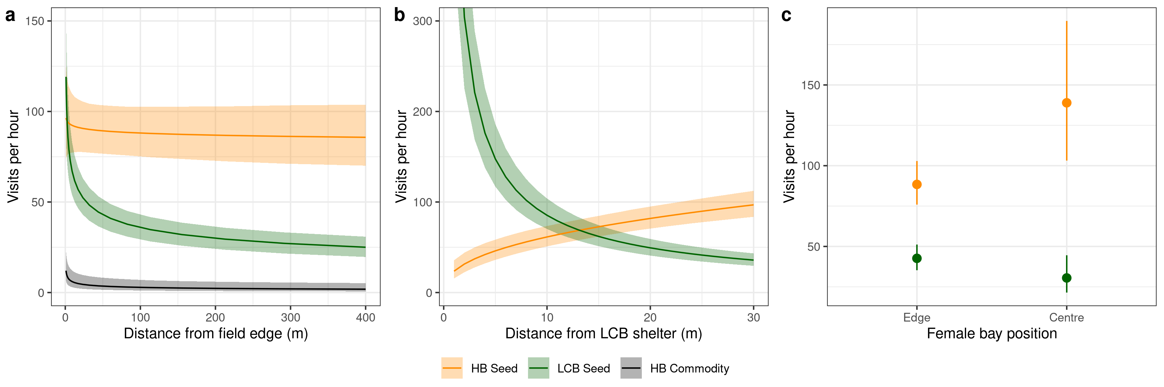

Effect of distance from a) honey bee apiaries, b) leafcutter shelters, and c) female bay position on visitation rates. Commodity fields are shown at a stocking rate of 40 hives (black line), while stocking rates are at 160 hives in seed fields (yellow line).

## Pollen Deposition

LCB visitation increased pollen deposition in seed canola fields, but honey bees did not increase pollen deposition in commodity or seed canola fields (Figure 3a). Pollen deposition on stigmas was high in commodity canola (mean: 293 grains/stigma, SD: 385, range: 0–3981), but honey bee visitation had no effect. Pollen deposition declined weakly with distance from the edge of the field (p0.09), but this only amounted to a 6% average decrease (290 grains/stigma at the field edge vs. 240 at field centre, Figure 3b). In seed canola, pollen deposition was much lower overall (mean: 22 grains/stigma, SD: 43, range: 0–578), and decreased from 26.3 grains/stigma at the edge to 11.5 at the centre of the field (Figure 3b), independent of bee visitation. LCB visitation increased pollen deposition from 13 grains/stigma at 0 visits/hr to 25 pollen grains at 100 visits/hr (Figure 3a), but there was no effect of honey bee visitation (p0.20), implying that most of the pollen deposition in seed fields is the result of LCB visitation. Pollen deposition also decreased from 15 grains/stigma at the edge of the female bay to 9 at the centre of the bay independent of visitation (Figure 3c), suggesting that bees crossing over into the male bays may deposit less pollen as they move towards the centre.

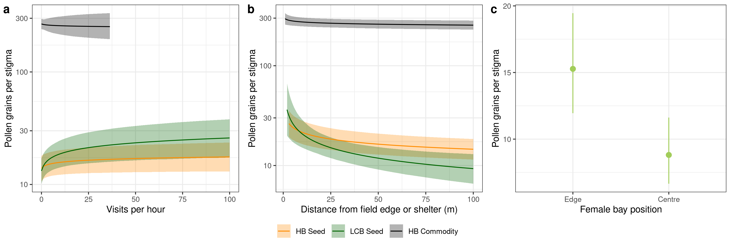

Effect of a) visitation rate, b) distance from apiary (HB) or shelter (LCB), and c) female bay position on pollen deposition.

## Seed Production

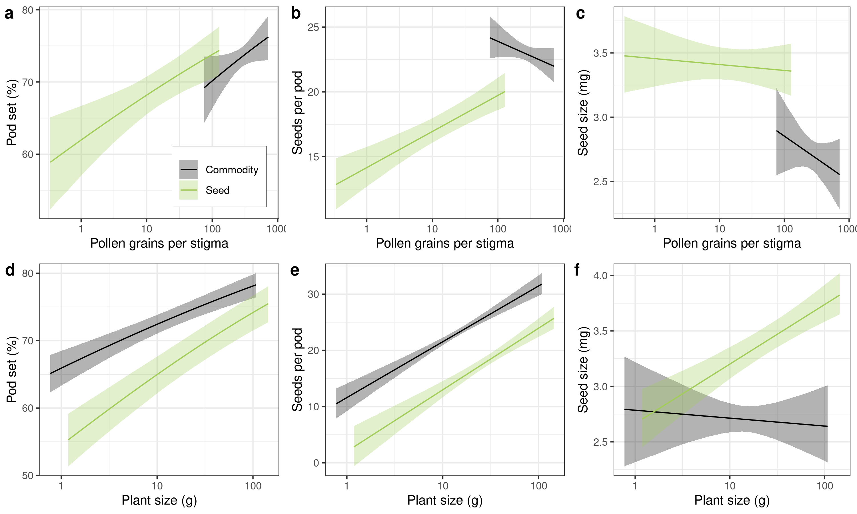

Marginal effects of pollen deposition (top row) and plant size (bottom row) on flower survival, seeds per pod, and seed size.

Commodity canola produced fewer flowers per plant than seed canola (mean: 196 vs. 461), and also produced fewer pods per plant (143 vs. 299, Table S1). In contrast, commodity canola also produced more seeds per pod than seed canola plants (mean: 23 vs. 16), but seed size was lower in commodity canola than seed canola (2.74 vs. 3.43 mg/seed). Finally, commodity plants were also lower-yielding than seed canola plants (mean: 6.8 vs. 9.5 g seed per plant), but produced more seeds per gram of vegetative biomass than seed canola plants (mean: 0.38 vs. 0.32), likely due to lower pollen limitation.

Plant size had by far the strongest positive effect on the number of pods produced (see large plant paths in Figure 1), and there was evidence of pod set suppressing flower production, but pollen only directly affected seed production in seed canola. Pollen deposition did not alter seed production in commodity canola (Figure 4a,b,c), nor was there a direct effect of honey bee visitation or distance from field edge, at least at the levels we observed. In both commodity and seed canola, plant size had a strong positive effect on percent pod set and seeds per pod, but did not increase seed size in commodity canola (Figure 4d,e,f). Pod set in seed canola decreased with distance away from the field edge and LCB shelters, and was also lower at the centre of the female bay (independent of visitation and pollen deposition). This distance effect was not seen in commodity canola, suggesting a more long-term pollen limitation effect in seed canola that was not captured by our snapshot of pollen and visitation. Plant density also had a positive direct effect on seed size in both crops; this likely indicates field areas with better microclimate or soil resources rather than density effects *per se*, as plants at edges of the field or in “field holes" are typically both smaller and less dense. Finally, pod set also had a strong negative influence on flowers per plant in both crop types, indicating that high pod set suppresses future flower production.

## Yield simulations

Our path analysis simulations further confirmed the results of the analysis: HB visitation had little effect on yield in either crop type, but LCB visitation improved yield in seed crops. The simulations showed no large effect of HB stocking on seed size or total yield in commodity fields (Figure 5a and b, respectively), aside from the effect associated with distance from the edge of the field. Similarly, the simulations for seed fields showed a small increase in seed size and total yield with distance from the HB hives at the field edges, but the effect of distance from the leafcutter shelters was much more dramatic (compare the spacing of isolines along the x-axis and y-axis in Figures 5c and d). Simulations run separately for the edge and centre of the female bay revealed that not only are total seed size and total yield lower at the bay centre, but that the effect of HB distance is effectively *nil* at the bay centre (yield isolines are essentially horizontal in bay centre, and slightly tilted at the bay edge, Figure 5d and f). Interestingly, the simulations also showed evidence of nonlinear behaviour occurring in the centre of seed field bays, where a local minima in yield appears at approximately 25 m away from HB hives and 45 m away from LCB shelters (Figure 5)f), likely because of an interaction between the components of yield (seeds per pod, pods per plant, and weight per seed).

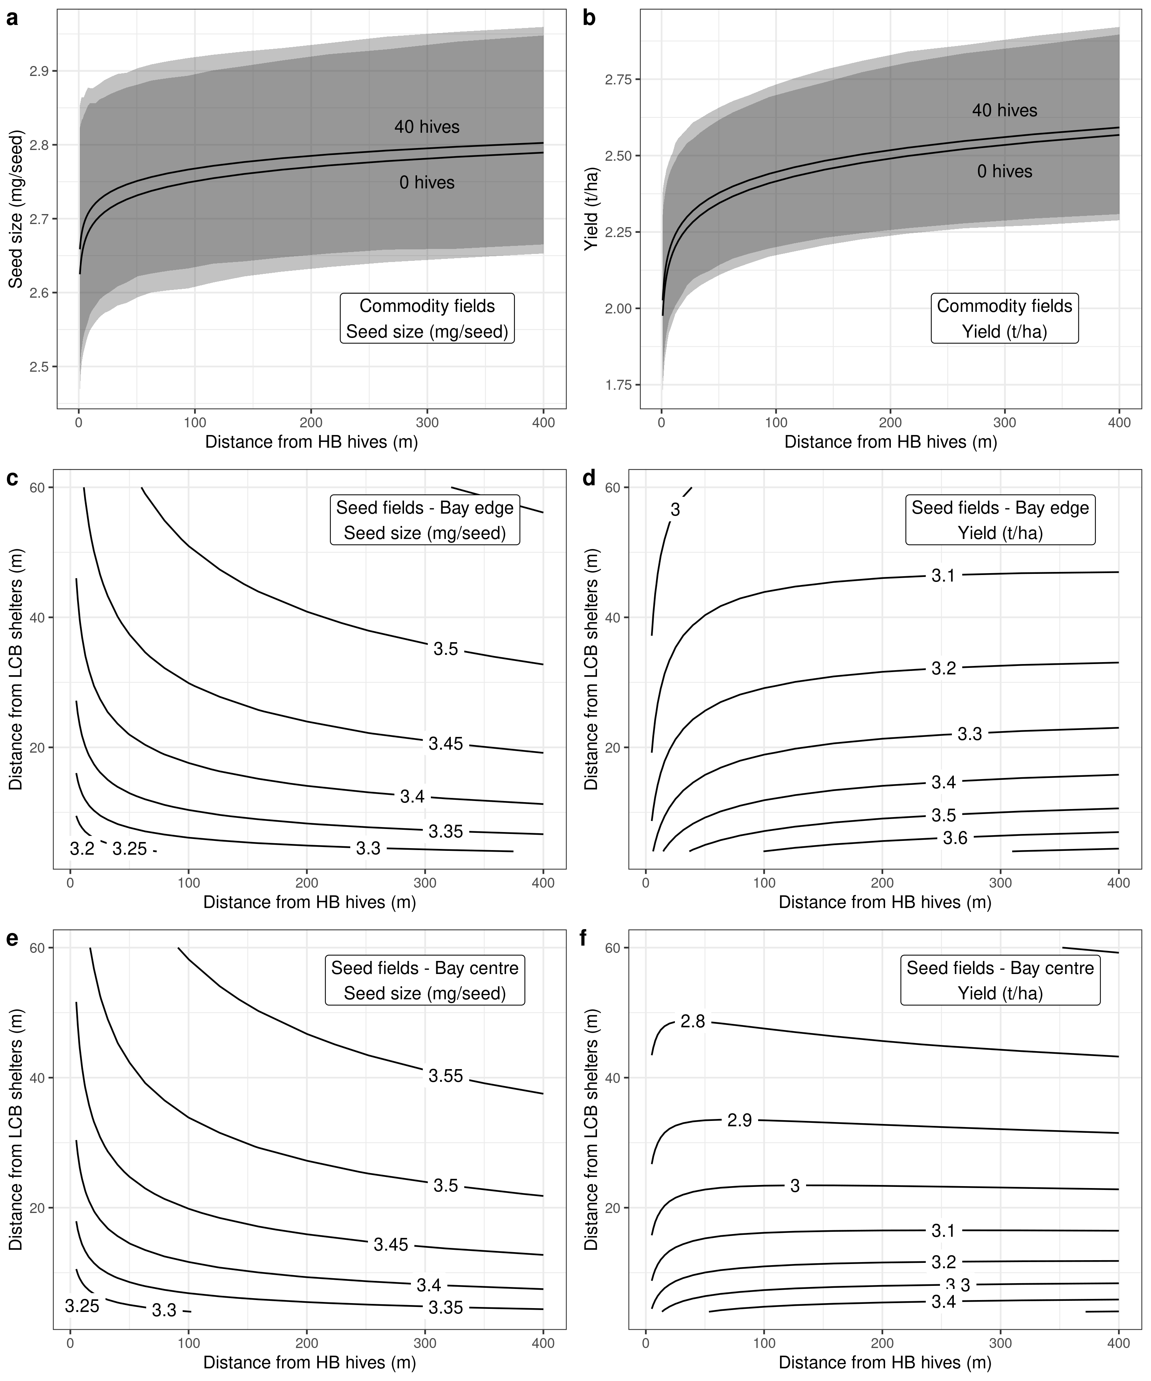

Effect of honey bee distance and leafcutter distance on seed size (mg/seed, first column) and total yield (tonnes/hectare, second column), using coefficients from paths for simulation, while holding plant density constant at its mean value. Shaded areas shown in a & b are 95% quantiles for the simulations. Lines on panels c - f are isolines of constant seed size (c, e) or yield (d, f).

# Discussion

We examined how bee visitation contributes to pollen deposition and seed yield in two different canola crops, and showed a strong link between visitation and yield in seed canola, but not in commodity canola. HB and LCB visitation decreased with distance from their respective hive or shelter, but unexpectedly, LCBs visited more frequently at the edge of the crop. HB visitation had little direct influence on pollen deposition in either crop type, while LCB visitation had a positive effect on pollen deposition in seed canola. We found that commodity canola production is largely limited by plant size, while seed canola production is limited by both pollen and plant size. Finally, our simulation results from the path analyses confirmed this, and showed the strong influence of LCB visitation on seed size and yield. These results provide more mechanistic information on the value of pollination services in commodity and seed canola crops, and show how a statistical-mechanistic model of seed production provides richer insight into the process of seed production than linear models alone.

## Bee visitation

HB visitation in both field types declined with distance into the field, but overall visitation was much higher in seed fields than commodity fields, due to the higher HB stocking rate used in seed fields (3.6 vs. 0.6 hives/ha). Since HBs travel to the crop from their hive outside the edge of the field, this decline was not surprising , but we did not expect a similar decrease in LCB visitation with distance into the field, as their shelters are located *within* the field. This decrease with distance into the field may have been caused by LCBs migrating from shelters at the centre of the field to the edge , as female LCBs are central-place foragers and tend to not forage far from their nests . However, LCBs are not as constrained to a single nest as HBs are, and can drift between shelters within a given field . LCBs must also forage for leaf materials to create cocoons, but seem to prefer thinner leaves than canola, mainly plants in the families Fabaceae and Rosaceae . Since seed canola fields have very few weeds within the crop, LCBs at the centre of the field may have few choices of leaf material, or alternative pollen and nectar sources. Therefore, LCBs likely move from the shelters at which they were released to the shelters at the edge of the field, so as to gain access to better leaf material or more diverse pollen and nectar sources .

In seed fields, HB visitation was correspondingly lower in areas close to LCB shelters, suggesting competition between species. Lower HB visitation may have been caused by lower nectar and pollen resources, as areas close to leafcutter shelters can become depleted in nectar and pollen . HBs also suffer from direct interference by LCBs near to their shelters; during the study we observed LCBs directly harassing HBs during the plot-level observations, attacking HBs both on the flowers and in the air (also seen by and ). HB visitation and foraging behaviour varied strongly between the edge and centre of the female bays in seed fields, while there was little difference between LCB visitation rates. HB visitation rates were almost twice as high at the centre of the female bay, but there was no corresponding difference in LCB visitation between male and female bays; this may reflect a greater need for pollen among LCBs than HBs , as female canola plants produce only nectar.

Very few HBs in the female bay were pollen foragers (1.4%, see Table 3), meaning that foragers who have recently come into contact with pollen are rare. Both and showed that HBs exhibit floral fidelity during foraging trips, with minimal crossing between male and female bays (5% of observations, ), limiting pollen transfer between the male and female flowers. Side-working was a very common behaviour among HBs in commodity fields (65% of the total visits from HBs during 2015 were side-working), as well as the male bays of seed fields (36%), but not in the female bays (3%, Table 3). This behaviour is relatively common on male-fertile flowers of *Brassica* as well as other flowering crop flowers , and may be due to HBs avoiding contact with the stigmas to increase ease of access to nectar, or to reduce the amount of grooming needed during a nectar foraging bout. The foragers who were side-working tended to not switch to top-working (personal observation), so this is likely a consistent individual behaviour (at least in experienced foragers). Taken together, these pieces of evidence suggests that HBs have limited opportunities for pollen transfer in both commodity and seed fields, as they commonly engage in side-working behaviour in both field types, and pollen foragers typically avoid female bays in seed canola fields.

## Pollen deposition

HB visitation did not increase pollen deposition in commodity canola fields compared to unstocked fields, meaning that self-pollination are the likely agents of pollen transfer (*Brassica* flowers are not aligned for dispersal and deposition from the wind, so cross-pollination likely occurs mainly via insects ). However, wind-induced self-pollination (plant shaking) can increase yield in *Brassica* , and fields without bee pollination have outcrossing rates of about 20% within the field . HBs can assist in deposition of self-pollen, as found that *Apis dorsata* and *Apis florea* can both deposit 100-200 grains of pollen per visit on a canola flower (*B. napus* var. *Bulbul*). However, used male-sterile flowers from seed canola fields and found that HB pollen foragers deposited far less outcrossed pollen than previously reported ( 2 grains per visit), suggesting that much of the pollen deposited on commodity canola stigmas may be self-pollen. Because the overall pollen deposition rates found in this study were high, HB visitation seems to have made little difference in the amount of self-pollination, as large amounts of pollen were present on commodity canola stigmas even at the centre of unstocked fields. This suggests that commodity canola stigmas are largely saturated with self-pollen, effectively “swamping" any extra pollen deposition by HBs.

Our models also revealed that pollen-transferring behaviour of HBs is limited in seed fields, as deposition strongly increased with LCB visitation but not HB visitation. HBs in seed fields tended to visit more in the centre of the female bay, even close to the edge of the field, yet pollen deposition was still about 40% lower. LCBs switch between male and female flowers more frequently than HBs, travel further between flowers, transport more viable pollen, and tend not to side-work canola flowers , all of which may explain their higher pollination efficacy. Pollen deposition in seed fields also decreased with distance from the edge of the field, and was lower in the centre of the female bays independent of visitation, suggesting lower pollen transfer per visit. These may have been caused by two separate processes: a) low pollen carryover with distance into the female bays, and b) shorter trips between flowers at the centre of the field. Pollen carryover from the edge to the centre of the bay female is likely reduced as LCBs typically visit the edge of the female bay before venturing into the centre . *Bombus* take shorter trips between flowers under nectar-rich conditions , suggesting that HBs and LCBs may operate similarly at the centre of seed fields, resulting in lower pollen transfer. While manipulating nectar levels within a field to produce greater travel between flowers could be extremely difficult, this suggests that the optimal width of female bays within seed fields may be lower than is currently practiced.

While we found that HBs have no direct effect on pollen deposition in either crop type, they may have an indirect positive effect caused by: a) increasing airborne pollen from male-fertile flowers , b) lowering nectar and pollen standing crop, causing LCBs to travel further , or c) lowering floral fidelity on higher-rewarding flowers in the male bays . A simple test of this might be to remove HB hives from a seed field (mid-season) and observe changes in LCB visitation before and after the removal.

## Seed production

Plant size increased the proportion of pod set in commodity canola, but both plant size and pollen deposition increased pod set in seed canola, suggesting that both pollen deposition and plant resources constrain pod production. This is similar to the findings of and , who found that pod set in male-sterile plants responded positively to visitation, while male-fertile plants had no response (but see ). Both pod set and seeds per pod can increase with extra pollination , so the low influence of pollination in commodity fields may be due to a high overall level of pollen deposition (Figure 3). There was no additional effect of HB visitation on pod set, meaning that that HB visitation did not cause more pollen deposition or improve its quality through increased outcrossing (as in ), but this may depend on the variety . Flowers per plant was reduced by pod set, implying that high pod set suppresses further flower production or increases competition among pods for plant resources. The first scenario is more likely, as and both found that canola plants compensated for experimental removal of flowers by increasing branch and flower production, until the plant reached about 170 pods per plant (our plants had a mean of 143 and 299 pods per plant in commodity and seed canola, respectively). There were also effects of distance on pod set independent of pollen: pod set decreased with distance from the edge of the field, distance to LCB shelters, and was lower at the centre of the female bays. also found that pod set in male-sterile canola declined quickly with distance from the male-fertile plants (due to wind pollination), but the effect we found is likely related to the earlier effect of lower pollen carryover at the centre of the female bays, and possibly the centre of the field. Finally, the effect of plant size was roughly 6x larger than that of pollen deposition, indicating that the factors controlling plant size (e.g. fertilizer application, soil quality) likely constrain pod production more strongly than pollination alone .

We found that seeds per pod in commodity canola was mainly influenced by plant size, while both seed size and seeds per pod was influenced by both plant size and pollen deposition in seed canola. Extra pollination generally results in canola plants producing more, smaller-sized seeds (see review in , but see also ), as the plant re-allocates resources across a greater number of fertilized ovules. Similarly, canola plants can also increase the number of matured ovules depending on the available plant resources . Our results in seed canola fields showed that pollen deposition had a smaller effect than plant size for seeds per pod (Z = 3.8 vs. 6.1), suggesting that plant resources limit seed production more strongly than pollen deposition, while plant size was the dominant term for commodity canola fields (Z = 1.2 vs. 6.6). Seed size was affected only by plant size in seed canola, and was not affected by pollen or plant size in commodity canola. Plant size is a measure of the source of photosynthates available to the seeds, while fertilized flowers act as sinks of nutrients, but both of these measures are crude, as both sources and sinks of seed nutrients vary across the season . Canola growth is indeterminate, and poorly-pollinated plants respond by making more branches , so it may be that large, poorly-pollinated plants have more resources and low numbers of fertilized ovules per flower at the end of the season. While we did not quantify pod position on branches, the pods at the end of the branches did appear to have fewer seeds, meaning that variation within plants likely occurred because of late-season seed. Unexpectedly, plant density had a *positive* effect on seed size in both crop types, which may be caused by two different processes: a) plant density could be positively related to resource availability if plant survival is higher in plots with better growing conditions (i.e. Berkson’s paradox, ) or b) plant density may improve the microclimate conditions of the canola stand, reducing heat or desiccation stress on individual plants. We consider the first process more likely, as planting density under uniform conditions typically has little effect on seed size (). In summary, our results add to a growing body of literature on the context-dependent value of pollination services .

## Conclusion

This study has revealed some of the detailed aspects of pollination in commodity and seed canola crops. First, it shows how two important species of commercial pollinators decline with distance from their nesting sites, and how LCBs unexpectedly decline with distance from the edge of the field. Second, it sheds light on the relative importance of HBs and LCBs as pollinators, showing that levels of HB stocking used for honey production do not strongly influence yield in commodity canola crops, and the importance of LCBs as primary pollinators of seed canola. Finally, it contextualizes the value of pollination alongside plant resources, showing that plant resources and pollen limit production in seed canola, while only plant resources limit production in commodity fields. Our unique SEM approach allowed us to formulate and test relationships within a causal framework, which we consider to be extremely valuable, and highly underused in agricultural studies. Our model serves as an approximation of a dynamic process, but could be built upon by using dynamic linear models to examine how plants dynamically respond to changes in pollination. These would lend greater understanding to the process of hybrid seed production, and could be used to more accurately predict crop yields in novel scenarios.

# Appendix A: Additional figures and tables

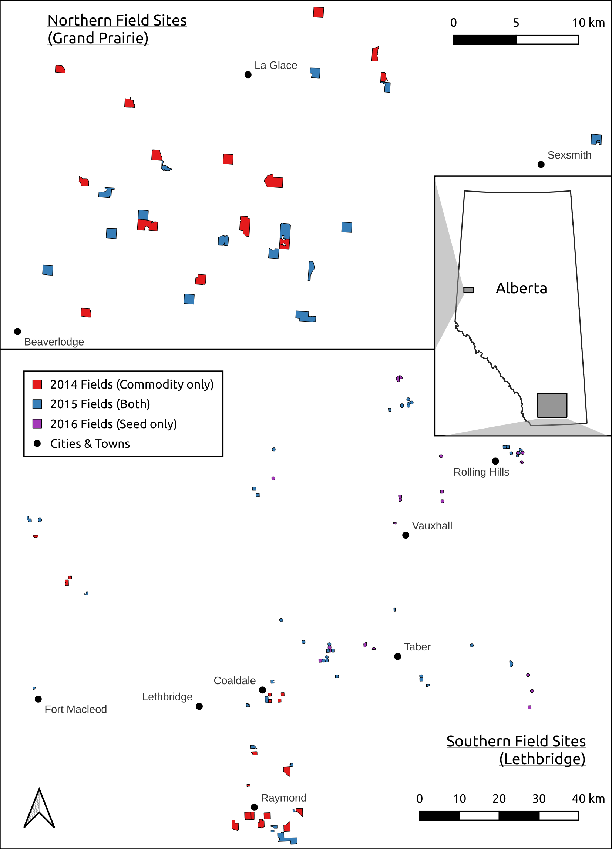

Map of sampled fields, showing locations of 29 commodity canola fields (14 during 2014, 15 during 2015), and 35 seed canola fields (15 during 2015, 20 during 2016). Seed canola is grown only in southern Alberta, while commodity canola is grown across both the northern and southern regions.

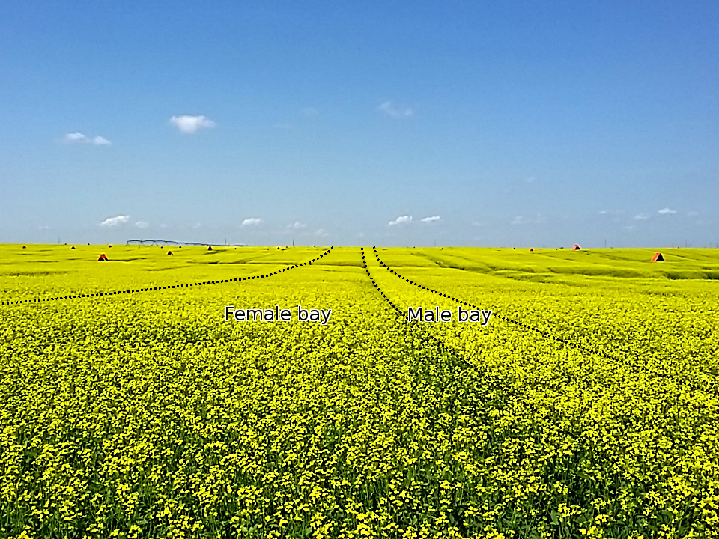

Hybrid seed field near Rainer, AB, showing the outlines of male and female bays in the foreground, with orange leafcutter bee shelters stationed throughout the field. The linear structure on the horizon is the central-pivot irrigation sprinkler.

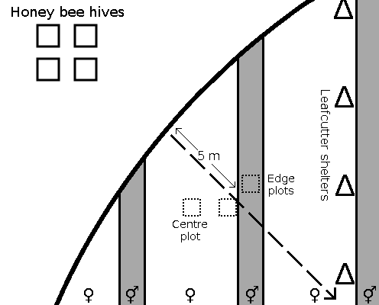

Plot arrangement for surveys in hybrid seed fields, showing hypothetical arrangement of leafcutter shelters (), and male-fertile () and female bays () at 5m from the edge of the field. Plots were placed along a transect (dashed line) from the field edge nearest to the set of honey bee hives. Plots were placed side-by-side in the male bay and edge of the female bay (“edge" plots), and at the 5m and 400m distances, an additional plot was placed in the centre of the female bay (“centre" plots). Note: this figure shows a small section of a much larger circular field.

Summary of variables used in structural equation models.

|  |  |  |  |  |  |  |
| --- | --- | --- | --- | --- | --- | --- |
| Field Type | Variable | Mean | Median | SD | Min | Max |
| Commodity | Number of hives | 14.80 | 0.00 | 17.03 | 0.00 | 40.00 |
| Distance to edge (m) | 137.48 | 20.00 | 195.02 | 1.00 | 500.00 |
| HB visitation (hr) | 10.31 | 0.00 | 28.80 | 0.00 | 218.18 |
| Flower density (m) | 470.33 | 448.00 | 231.32 | 52.00 | 1684.00 |
| Pollen per stigma | 293.33 | 155.00 | 385.04 | 0.00 | 3891.00 |
| Plant density (m) | 3.77 | 3.77 | 0.48 | 1.79 | 5.02 |
| Plant vegetative mass (g) | 18.15 | 14.32 | 14.07 | 0.77 | 107.66 |
| Plant seed mass (g) | 6.87 | 5.46 | 5.97 | 0.01 | 47.90 |
| Harvest index (g/g) | 0.38 | 0.37 | 0.16 | 0.00 | 1.89 |
| Flowers per plant | 196.09 | 156.50 | 150.96 | 13.00 | 1094.00 |
| Pods per plant | 143.15 | 112.00 | 114.64 | 5.00 | 892.00 |
| Seeds per pod | 22.96 | 23.60 | 4.97 | 4.60 | 35.40 |
| Seed size (mg) | 2.74 | 2.73 | 0.80 | 0.39 | 5.35 |
| Seed | Distance to edge (m) | 162.70 | 100.00 | 146.18 | 3.00 | 400.00 |
| Distance to LCB shelter (m) | 33.51 | 31.00 | 24.63 | 2.00 | 190.00 |
| HB visitation (hr) | 112.79 | 24.00 | 187.30 | 0.00 | 1290.00 |
| LCB visitation (hr) | 76.15 | 12.00 | 144.88 | 0.00 | 1272.00 |
| Bay Edge/Centre | 0.13 | 0.00 | 0.34 | 0.00 | 1.00 |
| Flower density (m) | 495.02 | 432.00 | 303.35 | 24.00 | 2686.40 |
| Pollen per stigma | 21.76 | 7.00 | 42.53 | 0.00 | 578.00 |
| Plant density (m) | 3.58 | 3.64 | 0.46 | 2.40 | 4.49 |
| Plant vegetative mass (g) | 30.32 | 25.19 | 21.16 | 1.18 | 144.32 |
| Plant seed mass (g) | 9.50 | 7.54 | 7.90 | 0.02 | 60.77 |
| Harvest index (g/g) | 0.32 | 0.33 | 0.15 | 0.00 | 1.21 |
| Flowers per plant | 461.32 | 362.50 | 326.59 | 26.00 | 2712.00 |
| Pods per plant | 299.41 | 244.50 | 207.68 | 10.00 | 1410.00 |
| Seeds per pod | 16.40 | 16.60 | 5.52 | 1.80 | 30.60 |
| Seed size (mg) | 3.43 | 3.42 | 0.88 | 1.04 | 5.59 |

[tab:dataSummary]

# Appendix B: Additional information on insect visitors

In 2015, we recorded whether honey bees were top-working or side-working flowers (see also ). Top-working bees landed on the top of the flower and inserted their proboscis down between the petals to access the nectaries of the flower, while side-working bees landed on the side of the flower and stole nectar by inserted their proboscis between the petals, avoiding contact with the stigma or anthers. Additionally, we recorded whether honey bees were pollen or nectar foragers (pollen foragers had a visible pollen load on their corbicula, while nectar foragers had none).

Pollen- and nectar-foraging honey bees had different patterns of side-working, both on commodity canola, and the male and female lines of seed canola. Side-working was common in nectar foragers, but was more common in commodity canola (64%) than in the male (36%) or female bays (2.8%) of seed canola, indicating that a large proportion of honey bees foraging on canola flowers may never come in contact with the stigmas. Pollen foragers were almost uniformly top-foragers in both commodity and seed fields (Table 3), and pollen foragers were much less common in the female bays (1.4%) than in the male bays (15%), or in commodity fields (18%). Therefore, foraging honey bees in seed canola fields tend to treat male-fertile flowers similar to commodity canola flowers, but seem to top-work flowers more in commodity canola than seed fields. Leafcutter bee foraging behaviours were not recorded, but seemed to almost exclusively top-work flowers in seed canola fields.

Number of flower visitors recorded over a total of 44.8 hours of observation in commodity fields (2014 and 2015), and 46.9 hours of observation in the seed fields (2015 and 2016). “Fly" refers to larger calyptrate muscoid flies (families Muscidae, Anthomyiidae, Caliphoridae), while “Hover fly" refers to Syrphid flies. “Other bee" included Halictid and Andrenid bees, while “Bumble bee" was Bombus spp. “Butterfly" refers to all visiting Lepidopterans, mostly Pierids.

|  |  |  |  |  |
| --- | --- | --- | --- | --- |
|  | Commodity fields | | Seed fields | |
| Taxon | Visits | % | Visits | % |
| Honey bee | 470 | 53.5 | 4850 | 77.1 |
| Fly | 222 | 25.3 | 74 | 0.878 |
| Hover fly | 94 | 10.7 | 151 | 1.79 |
| Other bee | 47 | 5.35 | 30 | 0.356 |
| Bumble bee | 25 | 2.85 | 0 | 0 |
| Butterfly | 16 | 1.82 | 0 | 0 |
| Leafcutter bee | 4 | 0.456 | 1675 | 19.9 |

[tab:propVisitors]

Foraging behaviours of honey bees on commodity and seed canola flowers, recorded during 2015. “Top" (top-working) indicates that the bee inserted their proboscis down between the petals from the top of the flower, while “side" (side-working) indicates that the bee fed from the side of the flower and did not contact the anthers or stigma. Pollen foragers had pollen visible on their corbicula, while nectar foragers had none.

|  |  |  |  |  |  |  |
| --- | --- | --- | --- | --- | --- | --- |
|  | Commodity fields | | Seed fields (female bay) | | Seed fields (male bay) | |
|  | Top | Side | Top | Side | Top | Side |
| Pollen forager | 44 | 2 | 12 | 0 | 115 | 0 |
| Nectar forager | 75 | 138 | 832 | 24 | 428 | 242 |

[tab:sideWorking]

# Appendix C: Additional information on models

## Commodity canola models

Formulas for commodity canola model using lmer-style R formulas. Terms on right side of indicate fixed effects, while terms in brackets indicate random effects (heirarchical intercepts). *distribution* indicates the type of probability distribution function used to model each variable.

Summary of parameters for commodity canola models

|  |  |  |  |  |  |  |  |  |  |
| --- | --- | --- | --- | --- | --- | --- | --- | --- | --- |
| Model | Parameter | Mean | SD | Median | Min | Max | P-value | N |  |
|  | Intercept | 3.76 | 0.05 | 3.77 | 3.66 | 3.87 | 0.0001 | 855 | 1.005 |
|  | HB distance | 0.02 | 0.01 | 0.02 | 0.00 | 0.04 | 0.0868 | 10154 | 1.000 |
|  | Sigma | 0.31 | 0.02 | 0.31 | 0.28 | 0.34 | - | 5039 | 0.999 |
|  | Sigma (field) | 0.37 | 0.04 | 0.37 | 0.30 | 0.46 | - | 3774 | 1.000 |
|  | Intercept | 5.24 | 0.24 | 5.24 | 4.77 | 5.72 | 0.0001 | 2108 | 1.001 |
|  | Plant density | -0.70 | 0.06 | -0.70 | -0.82 | -0.57 | 0.0001 | 2097 | 1.001 |
|  | HB distance | 0.03 | 0.01 | 0.03 | 0.01 | 0.06 | 0.0095 | 9212 | 1.000 |
|  | Sigma (field) | 0.22 | 0.04 | 0.22 | 0.15 | 0.29 | - | 1456 | 1.000 |
|  | Sigma | 0.64 | 0.02 | 0.64 | 0.61 | 0.68 | - | 7845 | 0.999 |
|  | Intercept | 5.74 | 4.70 | 5.70 | -3.62 | 15.01 | 0.222 | 1822 | 1.001 |
|  | Plant size | -1.66 | 0.98 | -1.66 | -3.60 | 0.25 | 0.0926 | 1632 | 1.001 |
|  | HB distance | 0.75 | 0.11 | 0.75 | 0.53 | 0.96 | 0.0001 | 6878 | 1.000 |
|  | Plant density | -0.41 | 0.74 | -0.42 | -1.86 | 1.06 | 0.5792 | 2243 | 1.001 |
|  | Sigma | 3.52 | 0.17 | 3.51 | 3.19 | 3.87 | - | 4976 | 0.999 |
|  | Sigma (field) | 3.55 | 0.39 | 3.53 | 2.88 | 4.40 | - | 4133 | 1.000 |
|  | Intercept | -1.98 | 0.45 | -1.96 | -2.89 | -1.17 | 0.0001 | 936 | 1.006 |
|  | HB distance | -0.31 | 0.10 | -0.31 | -0.50 | -0.13 | 0.0011 | 3526 | 1.001 |
|  | Number of hives | 0.72 | 0.15 | 0.72 | 0.43 | 1.04 | 0.0001 | 1534 | 1.003 |
|  | Flower density | 0.03 | 0.04 | 0.03 | -0.06 | 0.12 | 0.541 | 2397 | 1.000 |
|  | Sigma (field) | 1.44 | 0.34 | 1.43 | 0.80 | 2.14 | - | 494 | 1.014 |
|  | Phi | 0.35 | 0.08 | 0.34 | 0.22 | 0.53 | - | 1630 | 1.003 |
|  | Intercept | 2.56 | 0.04 | 2.56 | 2.50 | 2.63 | 0.0001 | 594 | 1.006 |
|  | Plant size | 0.94 | 0.01 | 0.94 | 0.92 | 0.96 | 0.0001 | 1709 | 1.002 |
|  | Pods per plant | -0.16 | 0.01 | -0.16 | -0.19 | -0.14 | 0.0001 | 2108 | 1.003 |
|  | Phi (field) | 0.16 | 0.02 | 0.16 | 0.13 | 0.19 | - | 3461 | 1.000 |
|  | Intercept (Phi) | 2.17 | 0.32 | 2.17 | 1.56 | 2.81 | - | 1517 | 1.001 |
|  | Plant size (Phi) | 0.66 | 0.11 | 0.66 | 0.44 | 0.87 | - | 1587 | 1.002 |
|  | SigmaPhi (field) | 0.66 | 0.12 | 0.65 | 0.45 | 0.90 | - | 844 | 1.005 |
|  | Intercept | 0.66 | 0.08 | 0.66 | 0.50 | 0.82 | 0.0001 | 1946 | 0.999 |
|  | HB visits | 0.00 | 0.03 | 0.00 | -0.05 | 0.05 | 0.96 | 3292 | 1.000 |
|  | Plant size | 0.13 | 0.03 | 0.13 | 0.08 | 0.18 | 0.0001 | 3345 | 1.000 |
|  | Pollen count | 0.16 | 0.11 | 0.15 | -0.05 | 0.38 | 0.1515 | 638 | 1.002 |
|  | Sigma (field) | 0.29 | 0.03 | 0.29 | 0.23 | 0.37 | - | 2675 | 1.000 |
|  | Phi | 3.35 | 0.07 | 3.35 | 3.21 | 3.48 | - | 3828 | 1.003 |
|  | Intercept | 25.07 | 1.77 | 25.07 | 21.64 | 28.54 | 0.0001 | 2277 | 1.000 |
|  | HB visits | 0.17 | 0.21 | 0.17 | -0.24 | 0.60 | 0.4284 | 4417 | 1.000 |
|  | Pollen count | -0.97 | 0.84 | -0.98 | -2.60 | 0.68 | 0.2447 | 707 | 1.003 |
|  | Plant size | 4.31 | 0.65 | 4.31 | 3.03 | 5.58 | 0.0001 | 2229 | 1.000 |
|  | Pods per plant | 0.56 | 0.29 | 0.56 | 0.00 | 1.12 | 0.0529 | 4888 | 0.999 |
|  | Flowers per plant | -2.80 | 0.65 | -2.79 | -4.08 | -1.55 | 0.0001 | 2105 | 1.000 |
|  | Sigma | 4.06 | 0.12 | 4.06 | 3.83 | 4.29 | - | 6604 | 1.000 |
|  | Sigma (field) | 1.98 | 0.26 | 1.96 | 1.51 | 2.53 | - | 2526 | 0.999 |
|  | Lambda | 2.00 | 1.03 | 1.74 | 0.84 | 4.64 | - | 3265 | 1.000 |
|  | Intercept | 0.64 | 0.54 | 0.64 | -0.40 | 1.72 | 0.2367 | 1402 | 1.000 |
|  | HB visits | 0.02 | 0.04 | 0.02 | -0.05 | 0.09 | 0.6113 | 2748 | 1.000 |
|  | Pollen count | -0.15 | 0.17 | -0.15 | -0.48 | 0.20 | 0.3744 | 358 | 1.008 |
|  | Seeds per pod | 0.00 | 0.01 | 0.00 | -0.01 | 0.02 | 0.4508 | 3348 | 1.000 |
|  | Plant size | -0.03 | 0.12 | -0.03 | -0.26 | 0.20 | 0.7955 | 1633 | 1.000 |
|  | Plant density | 0.30 | 0.08 | 0.30 | 0.14 | 0.45 | 0.0001 | 1704 | 1.001 |
|  | HB distance | 0.02 | 0.01 | 0.02 | -0.01 | 0.05 | 0.1686 | 1404 | 1.003 |
|  | Pods per plant | 0.11 | 0.04 | 0.11 | 0.02 | 0.19 | 0.0159 | 3037 | 1.000 |
|  | Flowers per plant | 0.11 | 0.12 | 0.11 | -0.13 | 0.34 | 0.363 | 1526 | 1.000 |
|  | Flower density | -0.03 | 0.01 | -0.03 | -0.04 | -0.02 | 0.0001 | 2213 | 1.003 |
|  | Sigma | 0.52 | 0.03 | 0.52 | 0.46 | 0.59 | - | 2100 | 1.000 |
|  | Sigma (field) | 0.47 | 0.05 | 0.47 | 0.37 | 0.58 | - | 2828 | 0.999 |
|  | Lambda | 2.71 | 0.48 | 2.63 | 2.08 | 3.86 | - | 1792 | 1.001 |

## Seed canola models

Formulas for seed canola model using lmer-style R formulas. Terms on right side of indicate fixed effects, while terms in brackets indicate random effects (heirarchical intercepts). *distribution* indicates the type of probability distribution function used to model each variable.

Summary of parameters for seed canola models

|  |  |  |  |  |  |  |  |  |  |
| --- | --- | --- | --- | --- | --- | --- | --- | --- | --- |
| Model | Parameter | Mean | SD | Median | Min | Max | P-value | N |  |
|  |  |  |  |  |  |  |  |  |  |
| Model | Parameter | Mean | SD | Median | Min | Max | P-value | N |  |
|  | Intercept | 3.60 | 0.06 | 3.60 | 3.47 | 3.73 | 0.0001 | 524 | 1.004 |
|  | HB distance | 0.06 | 0.01 | 0.06 | 0.04 | 0.07 | 0.0001 | 5750 | 0.999 |
|  | Sigma | 0.27 | 0.01 | 0.27 | 0.24 | 0.30 | - | 5199 | 0.999 |
|  | Sigma (field) | 0.36 | 0.05 | 0.36 | 0.28 | 0.48 | - | 4182 | 1.000 |
|  | Intercept | 6.08 | 0.25 | 6.08 | 5.57 | 6.56 | 0.0001 | 2480 | 1.000 |
|  | Plant density | -0.79 | 0.07 | -0.80 | -0.92 | -0.66 | 0.0001 | 2470 | 1.000 |
|  | HB distance | 0.07 | 0.01 | 0.07 | 0.05 | 0.10 | 0.0001 | 6446 | 0.999 |
|  | Sigma | 0.50 | 0.03 | 0.50 | 0.45 | 0.56 | - | 2332 | 1.000 |
|  | Sigma (field) | 0.15 | 0.04 | 0.15 | 0.08 | 0.23 | - | 1053 | 1.001 |
|  | Nu (DF) | 1.91 | 0.32 | 1.87 | 1.37 | 2.65 | 0.0001 | 2700 | 1.000 |
|  | Intercept | 0.48 | 0.56 | 0.46 | -0.58 | 1.64 | 0.3827 | 661 | 1.005 |
|  | HB distance | 1.11 | 0.12 | 1.11 | 0.87 | 1.36 | 0.0001 | 5389 | 1.000 |
|  | Sigma | 4.06 | 0.24 | 4.05 | 3.59 | 4.56 | - | 2404 | 1.001 |
|  | Sigma (field) | 3.48 | 0.47 | 3.44 | 2.70 | 4.49 | - | 2640 | 1.001 |
|  | Nu (DF) | 1.88 | 0.38 | 1.84 | 1.30 | 2.68 | 0.0001 | 1500 | 1.004 |
|  | Intercept | 3.08 | 0.10 | 3.08 | 2.87 | 3.28 | 0.0001 | 2722 | 1.002 |
|  | Flower density | -0.01 | 0.01 | -0.01 | -0.03 | 0.01 | 0.5267 | 4150 | 1.000 |
|  | HB distance | -0.02 | 0.05 | -0.03 | -0.12 | 0.07 | 0.6229 | 4410 | 1.000 |
|  | LCB distance | 0.42 | 0.09 | 0.42 | 0.24 | 0.58 | 0.0001 | 5053 | 1.000 |
|  | Bay centre | 0.45 | 0.21 | 0.45 | 0.07 | 0.88 | 0.0284 | 6486 | 0.999 |
|  | Phi | 0.72 | 0.09 | 0.72 | 0.55 | 0.92 | - | 4354 | 1.001 |
|  | Theta (ZI) | 0.32 | 0.03 | 0.32 | 0.26 | 0.38 | - | 3955 | 1.001 |
|  | Sigma (field) | 0.41 | 0.11 | 0.41 | 0.22 | 0.64 | - | 600 | 1.001 |
|  | Intercept | 2.25 | 0.14 | 2.25 | 1.96 | 2.51 | 0.0001 | 1734 | 1.002 |
|  | LCB distance | -0.79 | 0.07 | -0.79 | -0.94 | -0.65 | 0.0001 | 4016 | 1.000 |
|  | HB distance | -0.32 | 0.06 | -0.32 | -0.43 | -0.21 | 0.0001 | 5128 | 1.000 |
|  | Bay centre | -0.34 | 0.23 | -0.34 | -0.77 | 0.16 | 0.1458 | 6667 | 1.000 |
|  | Flower density | 0.03 | 0.01 | 0.03 | 0.01 | 0.05 | 0.0115 | 4364 | 1.000 |
|  | Sigma (field) | 0.63 | 0.13 | 0.62 | 0.40 | 0.91 | - | 1072 | 1.004 |
|  | Phi | 0.70 | 0.11 | 0.69 | 0.50 | 0.93 | - | 3097 | 0.999 |
|  | Theta (ZI) | 0.25 | 0.04 | 0.25 | 0.15 | 0.33 | - | 2383 | 1.000 |
|  | Intercept | 2.49 | 0.19 | 2.50 | 2.12 | 2.85 | 0.0001 | 1141 | 1.002 |
|  | HB visits | 0.05 | 0.04 | 0.05 | -0.03 | 0.12 | 0.195 | 2317 | 1.000 |
|  | LCB visits | 0.15 | 0.06 | 0.14 | 0.02 | 0.26 | 0.0155 | 2239 | 1.000 |
|  | Bay centre | -0.55 | 0.13 | -0.55 | -0.80 | -0.30 | 0.0001 | 2540 | 1.000 |
|  | HB distance | -0.17 | 0.04 | -0.17 | -0.25 | -0.09 | 0.0001 | 2265 | 1.003 |
|  | LCB distance | -0.35 | 0.14 | -0.35 | -0.63 | -0.07 | 0.0164 | 2513 | 1.000 |
|  | Flower density | -0.03 | 0.02 | -0.03 | -0.06 | 0.01 | 0.1284 | 2058 | 1.001 |
|  | Sigma (field) | 0.86 | 0.13 | 0.85 | 0.64 | 1.15 | - | 2978 | 1.000 |
|  | Sigma (plot) | 0.65 | 0.06 | 0.65 | 0.53 | 0.78 | - | 1142 | 1.003 |
|  | Phi | 0.82 | 0.04 | 0.82 | 0.74 | 0.90 | - | 5125 | 0.999 |
|  | Intercept | 3.05 | 0.04 | 3.05 | 2.96 | 3.14 | 0.0001 | 3283 | 0.999 |
|  | Plant size | 0.93 | 0.01 | 0.93 | 0.90 | 0.95 | 0.0001 | 3712 | 0.999 |
|  | Bay centre | 0.09 | 0.02 | 0.09 | 0.06 | 0.12 | 0.0001 | 6790 | 0.999 |
|  | Pods per plant | -0.14 | 0.01 | -0.14 | -0.17 | -0.12 | 0.0001 | 5503 | 0.999 |
|  | Sigma (field) | 0.08 | 0.01 | 0.08 | 0.06 | 0.11 | - | 2649 | 1.000 |
|  | Intercept (Phi) | 2.24 | 0.32 | 2.24 | 1.62 | 2.87 | - | 2875 | 1.001 |
|  | Plant size (Phi) | 0.38 | 0.10 | 0.39 | 0.19 | 0.57 | - | 2871 | 1.001 |
|  | Intercept | 0.18 | 0.12 | 0.18 | -0.05 | 0.40 | 0.1211 | 2261 | 1.000 |
|  | Pollen count | 0.12 | 0.04 | 0.12 | 0.03 | 0.20 | 0.0074 | 915 | 1.004 |
|  | Plant size | 0.19 | 0.03 | 0.19 | 0.14 | 0.24 | 0.0001 | 4570 | 1.000 |
|  | Bay centre | -0.21 | 0.06 | -0.21 | -0.33 | -0.10 | 0.0003 | 1886 | 1.000 |
|  | HB distance | -0.12 | 0.02 | -0.12 | -0.15 | -0.08 | 0.0001 | 1929 | 1.002 |
|  | LCB distance | -0.21 | 0.06 | -0.21 | -0.34 | -0.10 | 0.0005 | 2637 | 1.000 |
|  | Flower density | 0.00 | 0.01 | 0.00 | -0.02 | 0.01 | 0.5456 | 2998 | 1.000 |
|  | Sigma (plot) | 0.30 | 0.03 | 0.30 | 0.25 | 0.35 | - | 1367 | 1.004 |
|  | Sigma (field) | 0.37 | 0.06 | 0.36 | 0.27 | 0.49 | - | 2905 | 1.000 |
|  | Intercept (Phi) | 3.07 | 0.38 | 3.05 | 2.36 | 3.85 | - | 2268 | 1.004 |
|  | Plant size (Phi) | 0.22 | 0.12 | 0.22 | -0.01 | 0.44 | - | 2538 | 1.003 |
|  | Intercept | 25.38 | 2.29 | 25.48 | 20.64 | 29.38 | 0.0001 | 1651 | 1.001 |
|  | Pollen count | 1.21 | 0.32 | 1.20 | 0.61 | 1.87 | 0.0001 | 1046 | 1.002 |
|  | Plant size | 4.76 | 0.78 | 4.76 | 3.24 | 6.23 | 0.0001 | 1752 | 1.001 |
|  | Bay centre | -0.50 | 0.45 | -0.50 | -1.39 | 0.38 | 0.2639 | 5315 | 0.999 |
|  | HB distance | -0.02 | 0.12 | -0.01 | -0.25 | 0.21 | 0.881 | 3007 | 1.000 |
|  | Flower density | -0.11 | 0.06 | -0.11 | -0.23 | 0.00 | 0.0451 | 2596 | 1.000 |
|  | Pods per plant | 1.65 | 0.35 | 1.65 | 0.94 | 2.34 | 0.0001 | 2485 | 1.001 |
|  | Flowers per plant | -4.26 | 0.74 | -4.27 | -5.60 | -2.73 | 0.0001 | 1571 | 1.001 |
|  | Sigma | 4.25 | 0.16 | 4.25 | 3.92 | 4.56 | - | 2951 | 1.000 |
|  | Sigma (field) | 1.97 | 0.32 | 1.95 | 1.41 | 2.68 | - | 1767 | 1.002 |
|  | Lambda | 1.67 | 1.00 | 1.39 | 0.60 | 4.28 | - | 2448 | 0.999 |
|  | Intercept | 1.17 | 0.50 | 1.18 | 0.21 | 2.16 | 0.0189 | 2004 | 1.001 |
|  | Pollen count | -0.02 | 0.05 | -0.02 | -0.12 | 0.08 | 0.7002 | 2345 | 1.000 |
|  | Seeds per pod | -0.01 | 0.01 | -0.01 | -0.03 | 0.00 | 0.0765 | 3719 | 0.999 |
|  | Plant size | 0.23 | 0.06 | 0.23 | 0.12 | 0.34 | 0.0001 | 3607 | 1.000 |
|  | Plant density | 0.41 | 0.11 | 0.41 | 0.20 | 0.63 | 0.0002 | 1988 | 1.000 |
|  | LCB distance | 0.07 | 0.07 | 0.07 | -0.06 | 0.22 | 0.3146 | 4466 | 1.000 |
|  | Sigma | 0.75 | 0.03 | 0.75 | 0.69 | 0.81 | - | 3533 | 1.000 |
|  | Sigma (field) | 0.36 | 0.06 | 0.35 | 0.25 | 0.49 | - | 2060 | 1.000 |
|  | Lambda | 4.44 | 1.22 | 4.23 | 2.70 | 7.42 | - | 2125 | 1.000 |
| [tab:seedCoefs] |  |  |  |  |  |  |  |  |  |

## Total yield models

Formulas for total yield models are using lmer-style R formulas. Predicted yield for each plant was calculated as: pods per plant seeds per pod weight per seed. Terms on right side of indicate fixed effects, while terms in brackets indicate random intercepts (and slopes).

Summary of parameters for total yield models

|  |  |  |  |  |  |  |  |  |  |  |
| --- | --- | --- | --- | --- | --- | --- | --- | --- | --- | --- |
| Field Type | Parameter | Mean | SD | Z | median | Min | Max | p-value | N |  |
|  | Intercept | -0.318 | 0.042 | -7.62 | -0.317 | -0.397 | -0.236 | 0.000 | 982 | 1.000 |
|  | Predicted Yield | 1.007 | 0.018 | 55.64 | 1.007 | 0.972 | 1.044 | 0.000 | 1044 | 1.000 |
|  | Sigma (field intercept) | 0.119 | 0.041 | 2.89 | 0.112 | 0.051 | 0.216 | 0.004 | 292 | 1.020 |
|  | Sigma (field slope) | 0.026 | 0.019 | 1.37 | 0.023 | 0.001 | 0.072 | 0.170 | 295 | 1.013 |
|  | Sigma (plot intercept) | 0.389 | 0.037 | 10.47 | 0.388 | 0.318 | 0.465 | 0.000 | 506 | 1.005 |
|  | Sigma (plot slope) | 0.169 | 0.017 | 9.86 | 0.168 | 0.135 | 0.204 | 0.000 | 556 | 1.006 |
|  | Sigma | 0.253 | 0.008 | 33.30 | 0.253 | 0.239 | 0.268 | 0.000 | 2002 | 1.000 |
|  | Correlation (Int:Slope field) | -0.400 | 0.448 | -0.89 | -0.525 | -0.944 | 0.626 | 0.372 | 660 | 1.005 |
|  | Correlation (Int:Slope plot) | -0.989 | 0.007 | -140.44 | -0.990 | -0.998 | -0.972 | 0.000 | 936 | 1.005 |
|  | Intercept | -0.210 | 0.072 | -2.90 | -0.210 | -0.348 | -0.066 | 0.004 | 738 | 1.007 |
|  | Predicted Yield | 0.856 | 0.025 | 34.62 | 0.856 | 0.806 | 0.904 | 0.000 | 672 | 1.008 |
|  | Sigma (field intercept) | 0.040 | 0.018 | 2.28 | 0.038 | 0.011 | 0.079 | 0.022 | 226 | 1.005 |
|  | Sigma (field slope) | 0.010 | 0.007 | 1.56 | 0.009 | 0.001 | 0.023 | 0.118 | 217 | 1.005 |
|  | Sigma (plot intercept) | 0.097 | 0.013 | 7.26 | 0.097 | 0.072 | 0.124 | 0.000 | 470 | 1.005 |
|  | Sigma (plot slope) | 0.032 | 0.005 | 5.83 | 0.032 | 0.021 | 0.043 | 0.000 | 379 | 1.006 |
|  | Sigma | 0.289 | 0.012 | 23.59 | 0.289 | 0.266 | 0.314 | 0.000 | 1218 | 1.001 |
|  | Correlation (Int:Slope field) | -0.470 | 0.436 | -1.08 | -0.616 | -0.946 | 0.603 | 0.281 | 457 | 1.005 |
|  | Correlation (Int:Slope plot) | -0.902 | 0.038 | -23.81 | -0.909 | -0.954 | -0.808 | 0.000 | 486 | 1.007 |

[tab:totalYieldCoefs]

1. Corresponding author: samuel.robinson@ucalgary.ca